Mental Health Response Advisory Committee (MHRAC)
Meeting Minutes
August 15, 2023
Via Zoom

Board Members in Attendance
Maxwell Kauffman Disability Rights of New Mexico
Rachel Biggs Albuquerque Health Care for the Homeless
Commander Dietzel Crisis Intervention Division
Chief E. Jaramillo / Chief Ortiz Albuquerque Fire Rescue
Mariela Angel-Ruiz / Walter Adam Albuquerque Community Services
Paula Burton Peer Representative
Coty Maxwell Crisis Intervention Division
Mary Perez UNM Psychiatry & Behavioral Sciences
Betty Whiton NAMI
Gilbert Ramirez Family & Community Services
Robert Salazar NAMI Representative

Introduction to MHRAC
The Mental Health Response Advisory Committee (MHRAC) was created by the Court Approved Settlement Agreement (CASA). We’ve been around since day one and have a focus on three areas, resources, and resources being available to access different things within the city that APD and first responders can use as it impacts homelessness and mental health issues. We are also involved in training and policy. Training is one of those things we made a tremendous impact on. Policies are one of the things where the MHRAC is involved with assisting in writing, approving, and recommending policy as it relates again to the narrow focus; we think narrow, but sometimes it gets pretty wide-focused on how law enforcement interacts with those experiencing homelessness and those experiencing a mental health crisis.

Roll Call
There were eleven board members present, nine MHRAC members, and two representatives.
Adam Walters was a representative for Mariela Ruiz-Angel, and Chief Ortiz was a representation for Chief Jaramillo.

Welcome First-Time Guests
Rayna Torres
The new Program Coordinator of CIT ECHO, Department of Psychiatry and Behavioral Sciences, University of New Mexico (UNM).

Dr. Nicole Duranceaux, Psychologist
The new Director of Behavioral Sciences Service (BSS), Albuquerque Police Department (APD)

Approval of Meeting Minutes
1st Motion –
2nd Motion –
Minutes from the July 2023 meeting were approved by Maxwell Kauffman after confirming they were correct with the MHRAC Board Members.
Public Comment
No public comment

Nomination of New Board Members, if any, Rachel/Maxwell
No nominations were made this month but Maxwell Kauffman asked Dr. Duranceaux to consider becoming an MHRAC Board Member

Fathom Meeting AI Summary:
- Rayna and Dr. Nicole Duranceaux introduced themselves. Rayna mentioned the purpose of the CIT ECHO program.
- Maxwell and Brenda discussed the attendance and quorum requirements for the meeting.
- Maxwell discussed the approval of the meeting minutes and there were no objections, so they were approved.
- Maxwell mentioned the nomination of board members, but no nominations were made at that time.
- Deputy Chief JJ Griego introduced himself and discussed the technology projects they have been working on, including Smart 911 and its impact on mental health interactions. Deputy Chief JJ Griego explained the benefits of a service that allows individuals to provide detailed information about themselves and their households to emergency dispatchers. This information, including medical conditions and how individuals respond in certain situations, can help inform the response of emergency personnel and save time during emergency calls.
- Maxwell, Deputy Chief JJ Griego, and Paula Burton discussed the implementation of a service called Smart 911, which allows individuals to provide personal information to 911 operators. They addressed concerns about who has access to the information, the accuracy of the data, and the weight officers give to the reports.
- Walter announced that the Albuquerque Community Safety Department will be launching 24/7 operations starting on August 26th, with increased safety measures for responders. Aja also shared the news that the department was awarded a $2 million grant from the Department of Justice for a community project.
- Maxwell, Maria, Gilbert, Rachel, and Matt discussed various updates and plans related to increasing housing units, supportive housing, and mental health initiatives in the city. They also discussed the progress of the Gateway Center, including the transition of guests into the new space and the upcoming opening of the medical sobering center and medical respite.
- Matt, Maxwell, Sgt. Lowry, Lt Gonzales, Rachel, and others discussed various updates and initiatives within their department, including training, resource cards, policy changes, and involvement in officer-involved shootings. They also mentioned upcoming meetings and the need for board participation.

Smart911, Deputy Chief Jon Griego, APD Support Services Bureau
- The Bureau includes the vast majority of APD technology projects.
- Real Time Crime Center (RTCC)
- Emergency Communications Center (ECC) (911)
- Records
- Everything that has a screen, battery, or has a plug.
- We have been working on Smart911. It is where people can sign up and register to provide their information for this service.
- When they call 911 the information that they provide will then be transmitted to APD.
- The Smart911 Website is https://www.smart911.com/ where one would go to sign up for the service.
- Once you sign up, any information that you provide when you call 911 is transmitted to the dispatcher.
- This information can better inform APD and the Fire Department.
- You can customize the information for each person in the household (i.e. language, medical information, etc.)
- There is a great deal of medication that you can enter as well as advanced directives. Enter any kind of documentation that you want.
- There is a separate section for Neurological Behavioral Cognitive Conditions. You can check off whichever applies and how you respond to those situations.
- The intent of this is if you have to call dispatch (911), the dispatcher can immediately inform the officer of the information you provided.

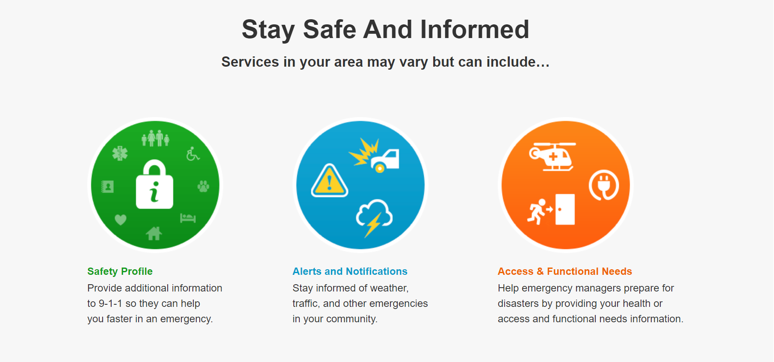

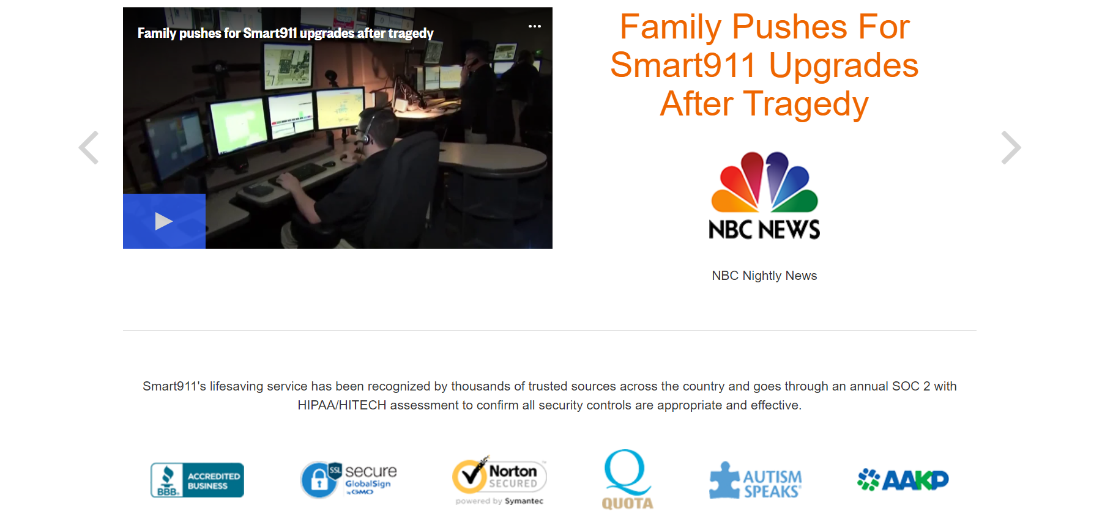
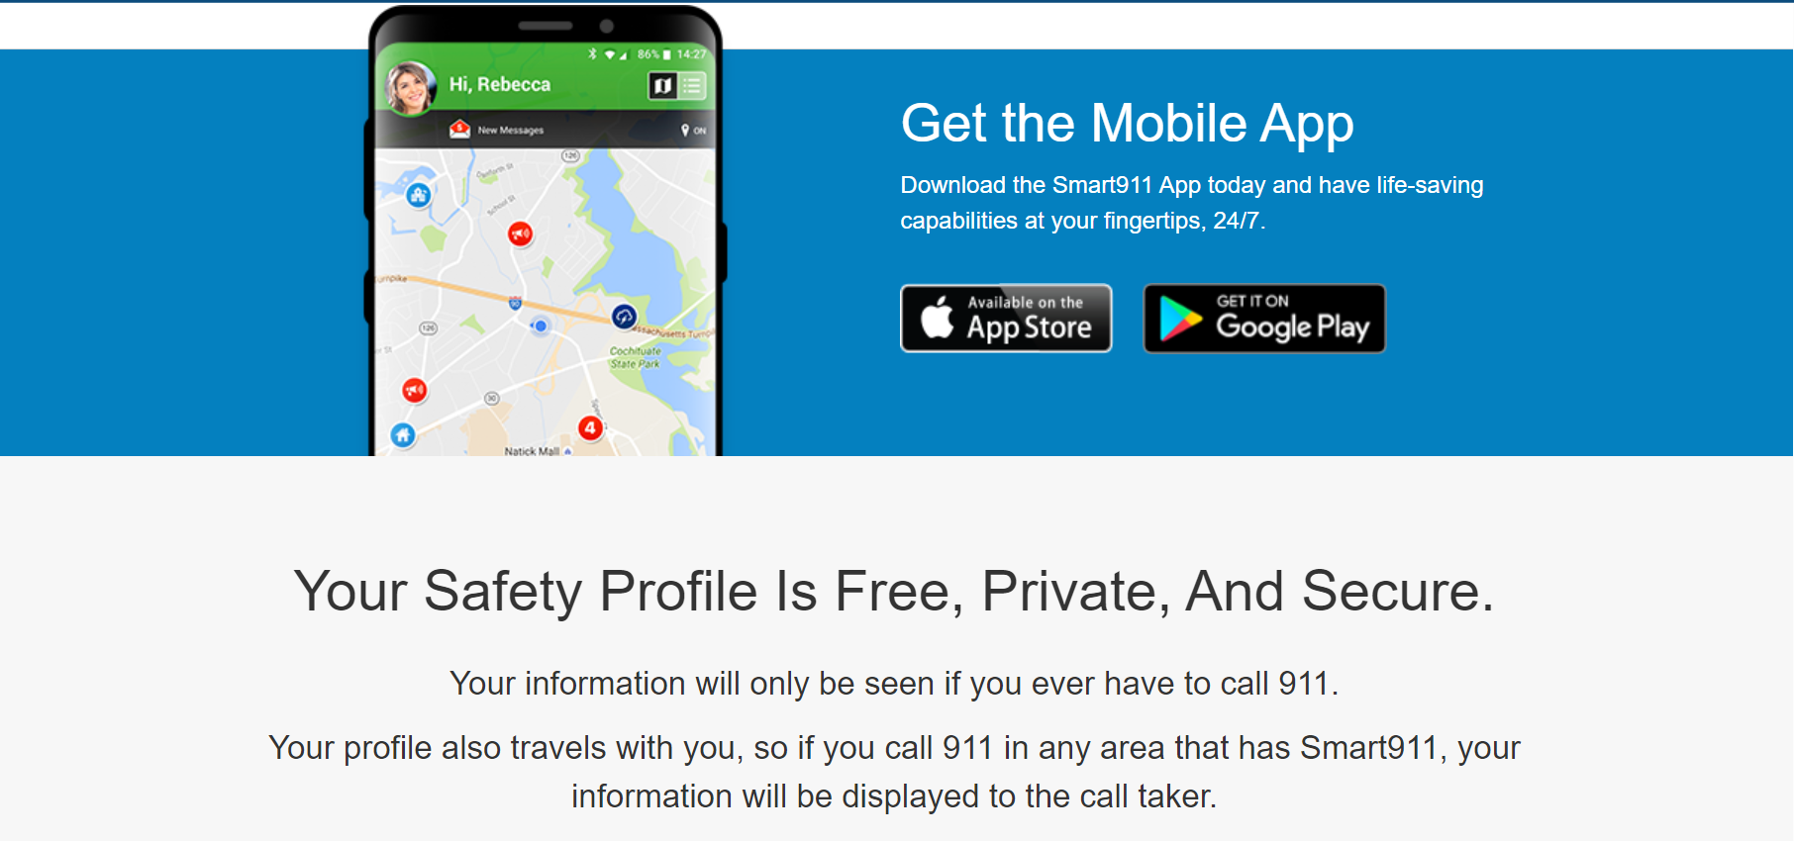
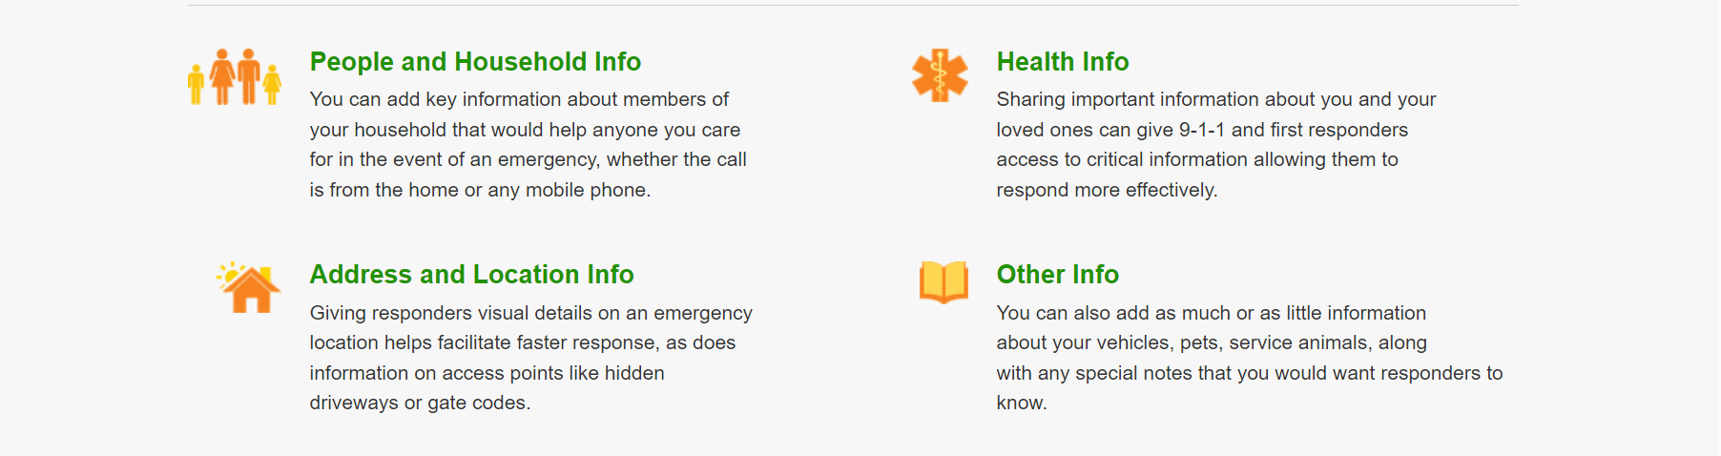

Albuquerque Community Safety (ACS) Update, Walter Adams
- We did our shift bid last week. We plan to launch graveyard and go 24/7 beginning August 26, 2023.
- Some safety features that we have added is increased lighting on the vehicles
- We have added spotlights and increased the emergency lighting. We want them to be more noticeable during that graveyard shift.
- We have added lights inside the vehicle that the responder can use to document information.
- We have purchased reflective vesting that says Albuquerque Community Safety (ACS) and the ACS logo.
- We purchased high aluminum flashlights.
- The Albuquerque Community Safet Department was awarded a Department of Justice Discretionary Community Project funding grant in the amount of $2 million that comes from the Department of Justice.

Gibson Health Hub, Family & Community Services Update, Maria Wolfe, Dr. Azka Naru, and Gilbert Ramirez
- Maria Wolfe’s new role in the city is the Homeless Innovations Officer
- I am trying to delve into the various programs and services that we are offering to help people who are unhoused at this time.
- I am looking into what is working, where we need to improve the scope of our contracts with various providers, building those partnering relationships, looking at other creative solutions, and hearing from a variety of folks.
- I am doing a lot of outreach.
- We have moved our guests into the newly constructed space and we are keeping it tight on the security pieces.
- Right now it is the women we are working with.
- Gilbert Ramirez oversees the Medical Sobering Center project and demolition has been moving forward for about a month now.
- We are still hoping to open the MSC in the early spring which would bring 48-50 beds for folks who have intoxication levels that are too high.
- The RFP for bids is being pushed up because it does have some federal funding so we have to follow that procurement. Hopefully, we will review them by the end of September and announce who the selected contractor will be for the building of the medical respite.
- The Engagement Center is where we allow our nonprofits to be a part of the services for the folks who are staying there in any capacity.
- We have multiple (12-13) providers coming in.
- We are providing service with the Department of Workforce Solutions and the Department of Health.
- We have a Barber Shop.

CIU, APD, and BSS Report and Update, Commander Dietzel, and Sgt. Tinney
- The CIU has done all mandated Reality Base Training (RBT) and RBT scenarios.
- The coordinators are conducting in-person refresher briefings for every shift and squad in the entirety of APD and are almost done. It has been beneficial because we are not getting as many mandated training referrals to go over de-escalation techniques with officers.
- We are moving out towards group homes, and hospitals, and partnering with AFR.
- The division has also completed a two-hour block of refresher training that MHRAC reviewed a few months ago. And that went out to every office on the force as well.
- We will be conducting interviews for Mobile Crisis Team (MCT) Officers. We have two vacancies.
- ACS has hired another clinician so we are going to back up to four full-time teams fairly soon.
- Right now we only have two full teams and a half-ish team, meaning one team is being covered by overtime right now.
- In July we had 543 referrals just from field officers.
- ACS is helping us out with the calls that would have gone to COAST. The CIU referred about 175 last month.

MHRAC Sub-Committee Report and Updates
Training Sub-Committee
We are going to hold off on some discussion for David, who will be back next month.

Inforshare/Resources/Policy Sub-committee, Commander Dietzel
- We had a really quick meeting.
  - Ordered 5000 revised Resource Cards. Karen Navarro and her team have worked on those updates for APD.
  - We reviewed the Internal Affairs Force Division (IAFD) Policy. Very minor changes to that policy.
    - What the detectives in that division do and the expectations for them
    - Grammatical updates
    - Added civilian detectives, which are non-sworn investigators. Just expanding the role of those investigators to be equivalent to a detective in that space.
We are going to be meeting with the academy to go over components of training for the Basic, 40-hour CIT, MOE, and eCIT just to make sure that we are viewing training as a whole umbrella instead of sliced throughout the training of the department. We are going to take out as much redundancy as we can that we sort of overlap in training in the academy and throughout an officer’s career.

MHRAC Final Discussion, Maxwell Kauffman
- Rachel, Commander Dietzel, and Max along with others in the city are trying to figure out a way for MHRAC to get more involved with Officer Involved Shooting (OIS) that involves people with behavioral crises or experiencing homelessness.
- We are still rooting for some help to get us into ordinance.

Meeting Transcribed by Fathom and Revised by Brenda Vigil-Gallegos

Next meeting: September 19, 2023

